RUSSELL SULLIVAN

4055 Packard Ave

Saint Cloud, FL 34772

407-452-9406

[russellsullivan@tigercoding.com](mailto:russellsullivan@tigercoding.com?subject=)

[LinkedIn](http://www.linkedin.com/in/tigercoding)

## Profile

Programmer with five years of freelance mobile development experience, primarily focused on iOS. Created numerous apps in the iTunes App Store as well as several for Android and BlackBerry. Looking for employment with a company that has a strong focus in mobile development.

## Experience

## Freelance programmer, Saint Cloud, Florida — 2010 - present

Successfully completed over 66 contracted iPhone & Android applications with a very high customer satisfaction rating. My profile with client comments can be seen here (be sure to click the “lifetime” tab on the right side of the page): <https://www.elance.com/s/quality_coding/>

Furthermore, the variety of jobs I performed not only exposed me to a wide range of technologies, but also required I work with existing developers, alleviating the “lone wolf” programmer trait.

Some of the technologies I’ve worked with (but certainly not limited to):

Github, SVN, Yelp, Parse, Video editing, Unity 3d, Drop Box, custom Core Graphics controls, Geolocation, Localization, REST, PDF creation, porting between platforms, graphic asset editing, and many, many more.

## Working for a subcontractor for the USPS, Orlando, FLorida — 2004 - 2010

Postal freight distributor (non-programming position).

## Embedded testing programmer, Aerotron-Repco, Inc, Orlando, FLorida — 2002 - 2004

Programmed various applications to test electronic hardware. Required interfacing embedded devices with software, ensuring accurate performance specifications, and reporting device issues for electronics engineers.

## Skills

Primary programming skills include Objective-C and C++. Very familiar with the Cocos2d-x library having used it in several client projects. Currently extending Javascript skills.

In-depth experience with designing user interfaces and integrating graphics with applications via Adobe Illustrator and PhotoShop.

## formal Education

Valencia Community College — Technical Certificate in Programming, 2002

## Additional information

Abstract thinker, often identifying ‘bigger picture’ things that others do not.

Ability to explain ideas and concepts very clearly to others.

High degree of patience.

## Apps

Below is a collage of most of the app icons that I have worked on over the past five years. Please view the next pages for a few select examples. Most clients provided artwork and I provided the functional code.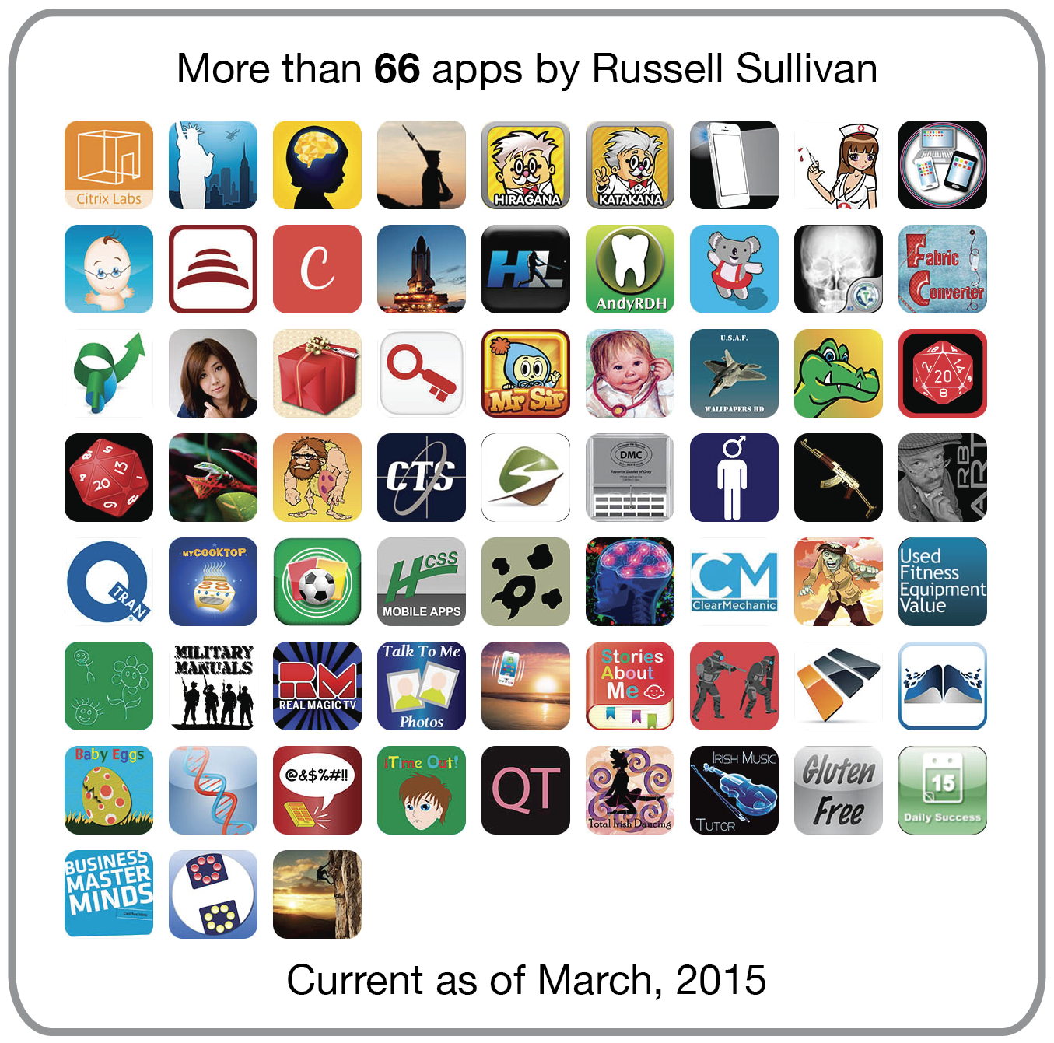

## Cube Free

I worked as part of a Citrix team to integrate API’s from Yelp and Foursquare into this MapKit-based social workspace sharing application, which uses Parse as a backend for data storage.

[iTunes Store](https://itunes.apple.com/us/app/cubefree-app-workspaces-cafes/id916978531?mt=8)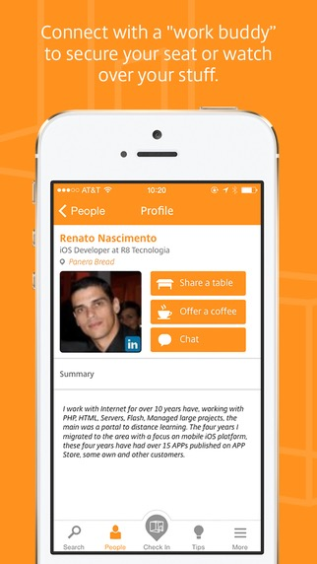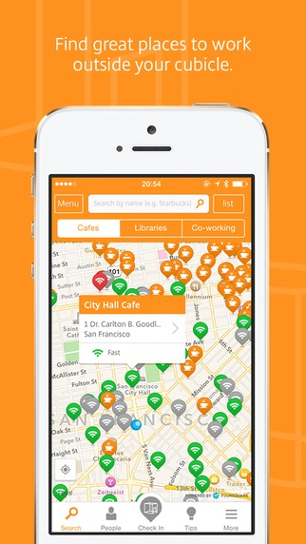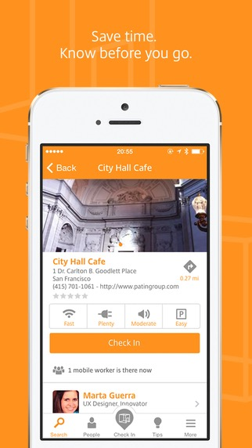

Watch the YouTube video [here](https://www.youtube.com/watch?v=HcMq1r_dGYs).

## Hitter’s Log

This application was created for a client and reached the top ten in the sports category on the App Store.

[iTunes Store](https://itunes.apple.com/us/app/hitters-log/id492636610?mt=8)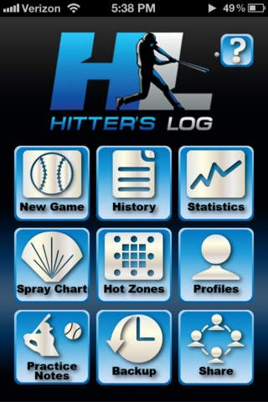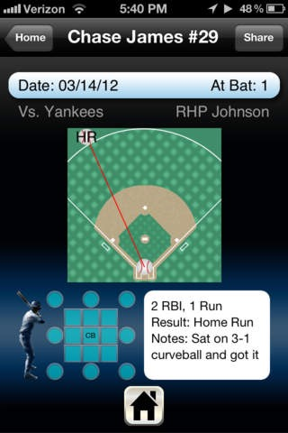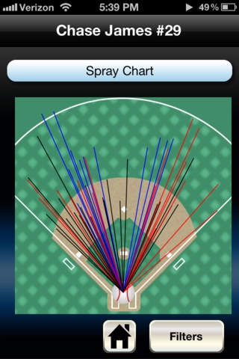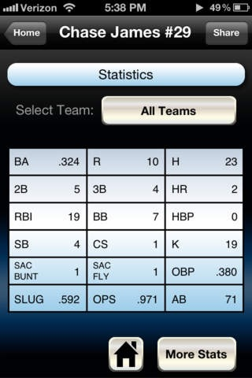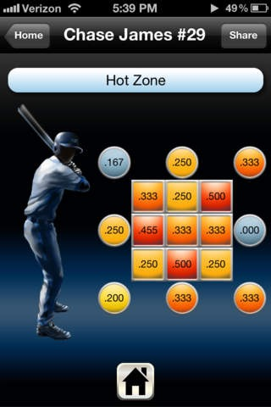

## Dr. Moku's Katakana Mnemonics

An amazing Japanese learning application that has several versions (Katakana, Hiragana, etc.) all published with the same code base.

[iTunes Store](https://itunes.apple.com/us/app/dr.-mokus-katakana-mnemonics/id452226776?mt=8)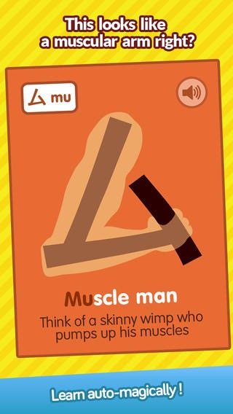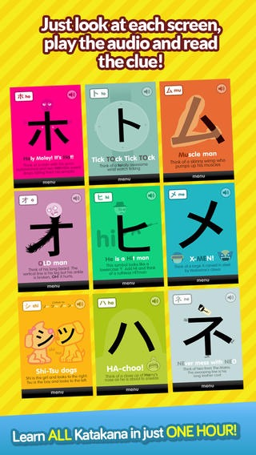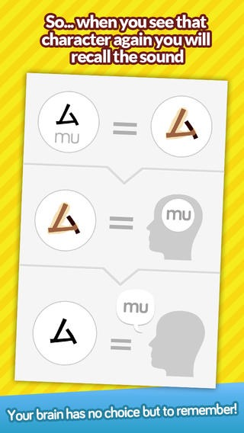

## Free Light

What started out as a test app evolved into an app with over half a million downloads. Have a look at the screen shots below, in particular the graphics, then read the note afterwards.

[iTunes Store](https://itunes.apple.com/us/app/free-light/id344352798?mt=8)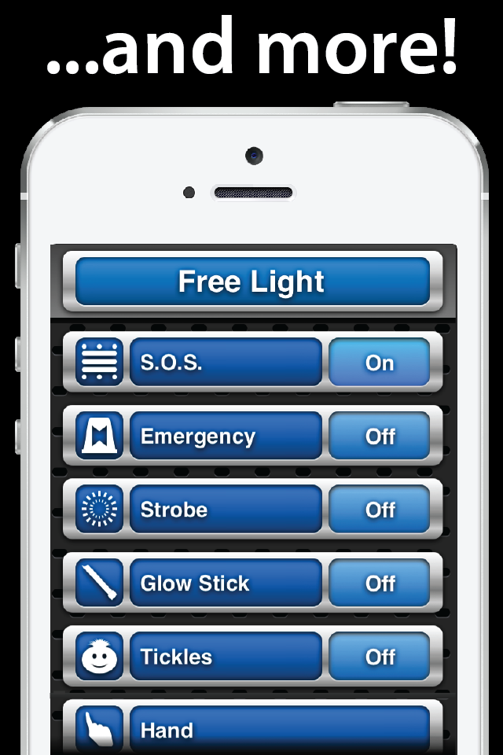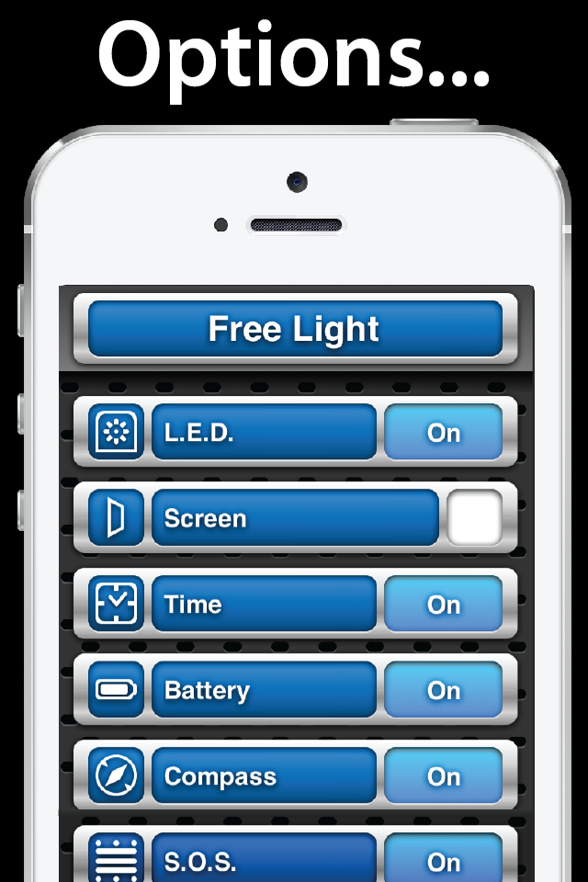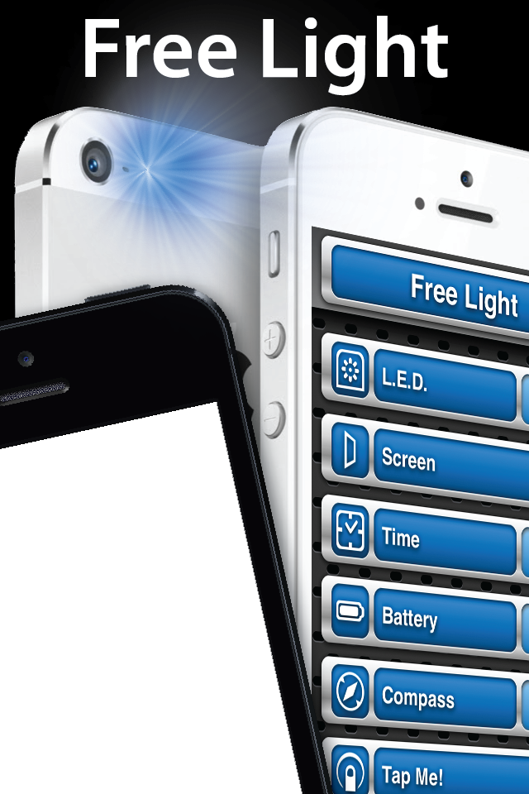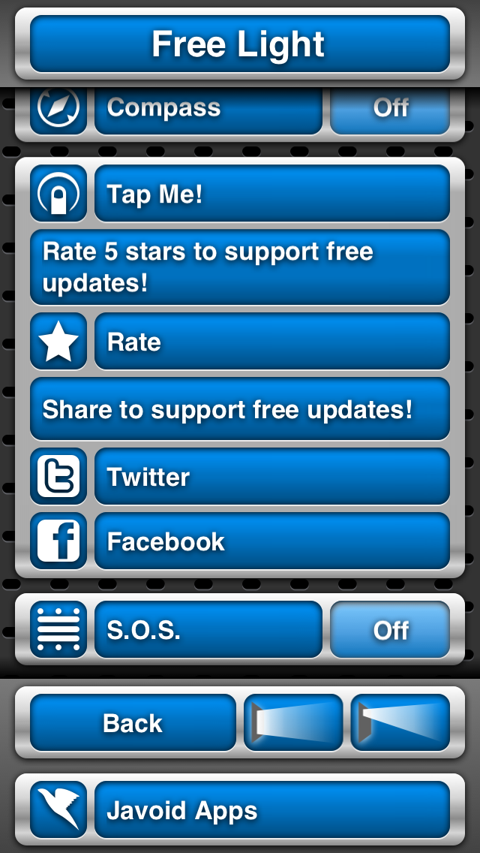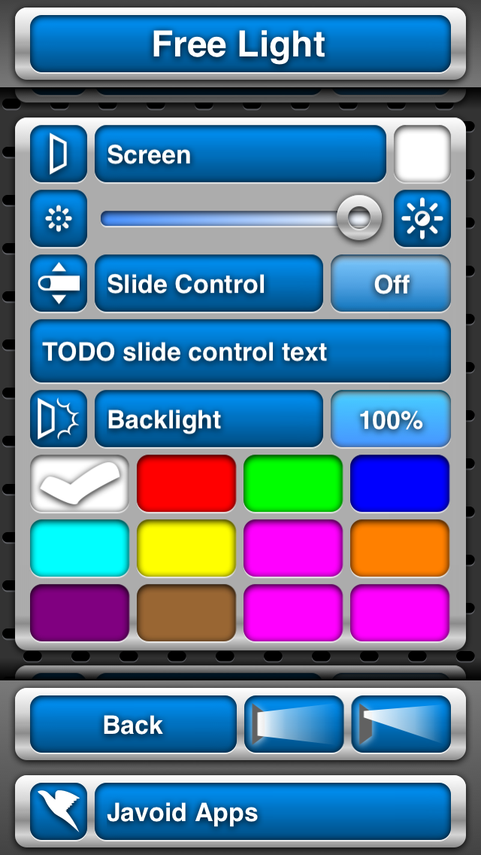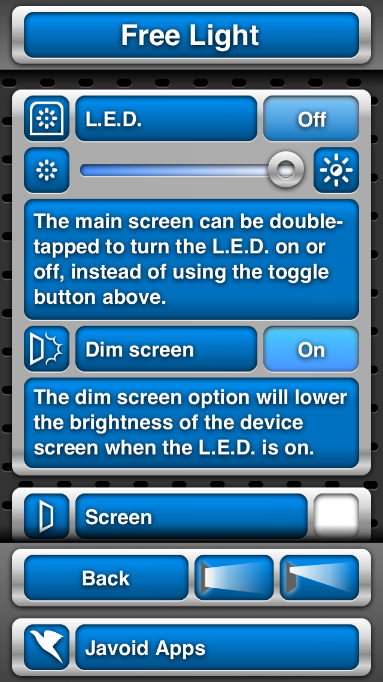

All the user interface images were created in Core Graphics code. Every menu item, button, icon, and animation was all done without including images in the app itself.

## Stories about me

An iPad application to track memories. Uses DropBox API’s to store data so photos and other information is never lost.

[iTunes Store](https://itunes.apple.com/us/app/stories-about-me/id531603747?mt=8)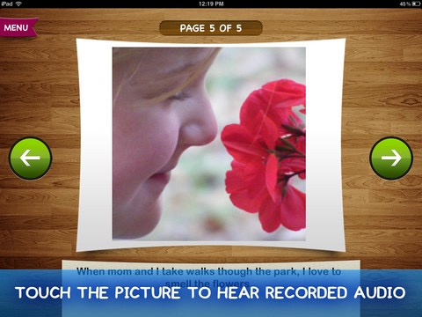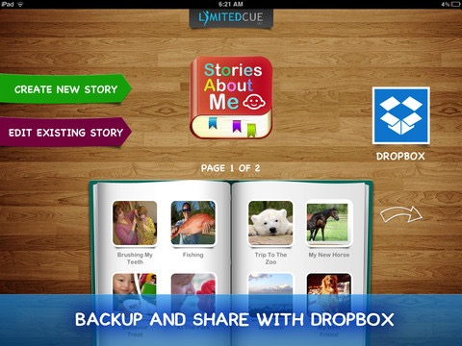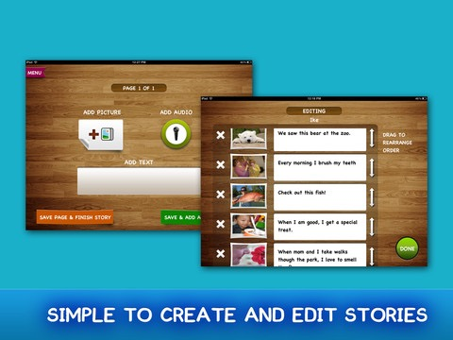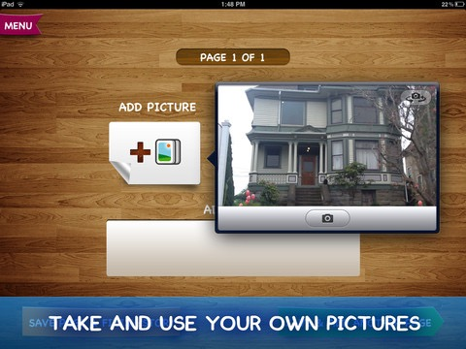

## Most important

Something I strive for in every application.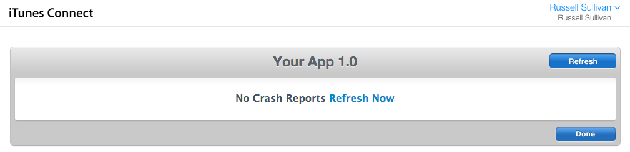

## proof of work

Viewable on my elance profile.